
ASSOSA UNIVERSITY
SUBMISSION DATE: 25/08/2018E.C
SUBMITTED TO:- MR CHALA
- YONAS AME-----------------------------------------------------------RU0067/17
- JUHAR HUSSEN-------------------------------------------------------RU0408/17
- MEKIDES GELAGAY--------------------------------------------------RU0366/17
- MARKOS MANDEFRO-----------------------------------------------RU0293/17
- KIFILE YOHANNES----------------------------------------------------RU0299/17
ID NUMBER
GROUP MEMBERS
COLLEGE OF COMPUTING AND INFORMATICS DEPARTMENT OF INFORMATION SCIENCE DATA STRUCTURE AND ALGORITHM GROUP ASSIGNMENT
#include <iostream>
1. Sorting Algorithms Implementation
#include <vector>
#include <string>
#include <iomaniP>
using namespace std;
struct SortResult {
string name;
int comparisons;
int swaps;
int totalOperations() const {
return comparisons + swaps;
}
};
// Simple Sort
SortResult simpleSort(vector<int> arr) {
SortResult result = {"Simple Sort", 0, 0};
int n = arr.size();
for (int i = 0; i < n - 1; i++) {
for (int j = i + 1; j < n; j++) {
result.comparisons++;
if (arr[i] > arr[j]) {
swap(arr[i], arr[j]);
result.swaps++;
}
}
}
return result;
}

//Bubble Sort
SortResult bubbleSort(vector<int> arr) {
SortResult result = {"Bubble Sort", 0, 0};
int n = arr.size();
bool swapped;
for (int i = 0; i < n - 1; i++) {
swapped = false;
for (int j = 0; j < n - i - 1; j++) {
result.comparisons++;
if (arr[j] > arr[j + 1]) {
swap(arr[j], arr[j + 1]);
result.swaps++;
swapped = true;
}
}
if (!swapped) break;
}
return result;
}

// Insertion Sort
SortResult insertionSort(vector<int> arr) {
SortResult result = {"Insertion Sort", 0, 0};
int n = arr.size();
for (int i = 1; i < n; i++) {
int key = arr[i];
int j = i - 1;
if (j >= 0) result.comparisons++;
while (j >= 0 && arr[j] > key) {
arr[j + 1] = arr[j];
result.swaps++;
j--;
if (j >= 0) result.comparisons++;
}
arr[j + 1] = key;
}
return result;
}

// Selection Sort
SortResult selectionSort(vector<int> arr) {
SortResult result = {"Selection Sort", 0, 0};
int n = arr.size();
for (int i = 0; i < n - 1; i++) {
int min_idx = i;
for (int j = i + 1; j < n; j++) {
result.comparisons++;
if (arr[j] < arr[min_idx]) {
min_idx = j;
}
}
if (min_idx != i) {
swap(arr[min_idx], arr[i]);
result.swaps++;
}
}
cout << "Sorted Data: ";
for(int val : arr) cout << val << " ";
cout << "\n\n";
return result;
}

int main() {
int n;
cout << "Enter the number of data items: ";
cin >> n;
if (n <= 0) {
cout << "Please enter a valid number of items." << endl;
return 1;
}
vector<int> data(n);
cout << "Enter the " << n << " unsorted integers separated by spaces:\n";
for (int i = 0; i < n; i++) {
cin >> data[i];
}
cout << "\nProcessing sorts...\n";
vector<SortResult> results;
results.push_back(simpleSort(data));
results.push_back(bubbleSort(data));
results.push_back(insertionSort(data));
results.push_back(selectionSort(data));
cout << string(55, '-') << "\n";
cout << left << setw(18) << "Algorithm"
<< setw(15) << "Comparisons"
<< setw(10) << "Swaps"
<< "Total Operations\n";
cout << string(55, '-') << "\n";
SortResult bestAlgo = results[0];
for (const auto& res : results) {
cout << left << setw(18) << res.name
<< setw(15) << res.comparisons
<< setw(10) << res.swaps
<< res.totalOperations() << "\n";
if (res.totalOperations() < bestAlgo.totalOperations()) {
bestAlgo = res;
}
}
cout << string(55, '-') << "\n";
cout << "\nCONCLUSION:\n";
cout << "Based on the given data, the most efficient algorithm is **"
<< bestAlgo.name << "**.\n";
cout << "It required the least amount of total operations ("
<< bestAlgo.totalOperations() << " combined comparisons and swaps).\n";

return 0;}
OUTPUT
Enter the number of data items: 5
Enter the 5 unsorted integers separated by spaces:
5 2 4 1 3

Processing sorts...
Sorted Data: 1 2 3 4 5

-------------------------------------------------------
Algorithm Comparisons Swaps Total Operations
-------------------------------------------------------
Simple Sort 10 7 17
Bubble Sort 10 7 17
Insertion Sort 9 7 16
Selection Sort 10 3 13
-------------------------------------------------------

CONCLUSION:
Based on the given data, the most efficient algorithm is **Selection Sort**.
It required the least amount of total operations (13 combined comparisons and swaps).
2.SEARCHING ALGORTHM IMPLEMENTATION
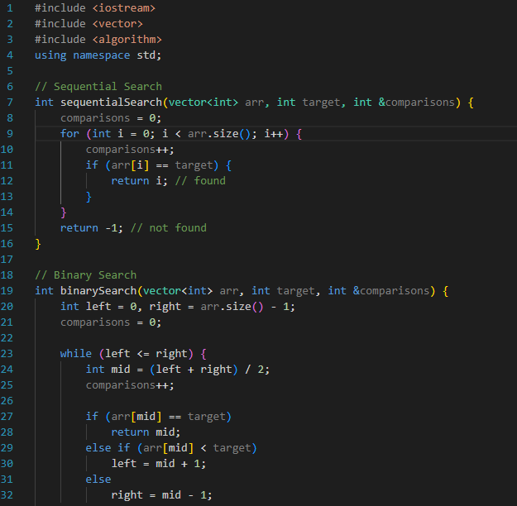
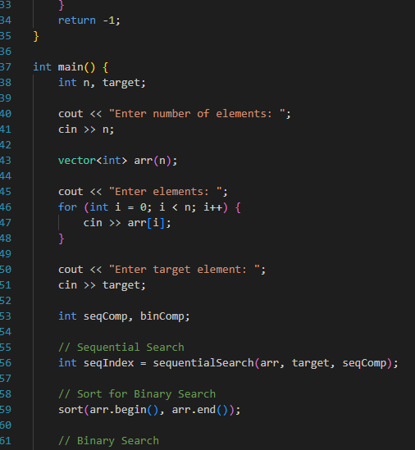

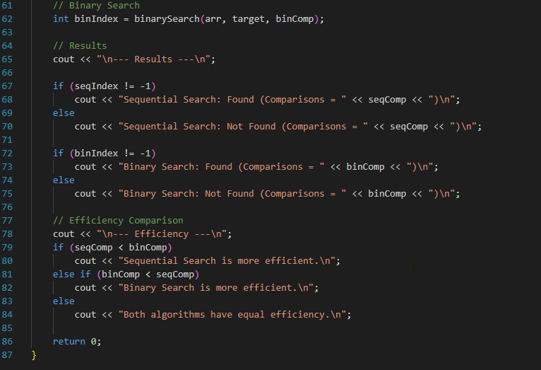

Enter number of elements: 10
Enter elements: 10 20 30 40 50 60 70 80 90 100
Enter target element: 70

--- Results ---
Sequential Search: Found (Comparisons = 7)
Binary Search: Found (Comparisons = 4)

--- Efficiency ---
Binary Search is more efficient.

